Supply Chain Management (SCM) — NPTEL
Week 11 · Session 4: SC Digital Twin — Network Optimization (Excel + Any Logistics)
1. Context — Moving from GFA to Network Optimization
- GFA (Sessions 2 & 3): found optimal DC location from scratch (1 DC, minimize transport cost)
- This session: Network Optimization — demand doubled, new factory needed, existing DC lease expiring
- Now must decide simultaneously: which factory to open, which DC to open, and how to route flows
- This is a more complex, realistic problem — goes beyond single facility location

Attribute | GFA (Session 2 & 3) | Network Optimization (This Session)
Question answered | WHERE to place a new DC from scratch? | Which factories/DCs to open AND how to route flows?
Objective | Minimize transportation cost | Maximize profit (Revenue − all costs)
Decision variables | xDC (lat), yDC (long) — 2 variables only | yi (factory open), zj (DC open), xij (flows), qjk (flows)
Facility options | Infinite possible coordinates | Fixed candidate locations — choose which to open
Variable type | Continuous — lat/long are real numbers | Mixed Integer — binary (yi, zj) + continuous (xij, qjk)
Solver method | GRG Non-linear (spherical distance is non-linear) | Simplex LP (all linear constraints and objective)
Cost components | Distance × demand × transport cost only | Fixed + production + inbound/outbound + transport costs
Excel limitation | Works for small scale | Works for small scale, Any Logistics for large scale

★ Network Optimization = decide which nodes to open (binary) AND how much to flow between them (continuous). Much richer decision than GFA.

2. Case Study — Pharma Company Network Redesign
Background
- Demand in western region will double in next 3 years — current capacity insufficient
- Management decides to set up a new factory at one of: Nashik OR Aurangabad
- DC in Mumbai (from GFA) lease is expiring — must relocate to one of: VAPI OR V1D (Viwandi)
- Markets remain: Pune, Mumbai, Ahmedabad, Surat — but demand is now doubled
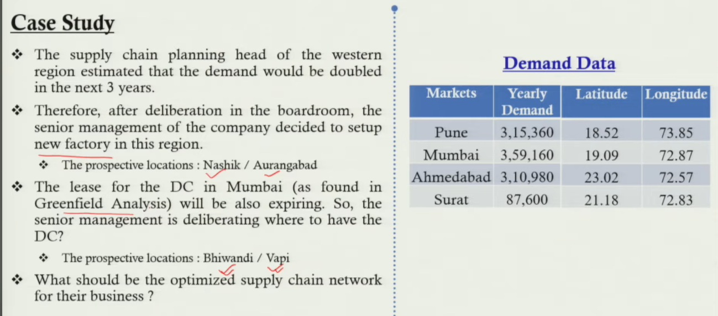
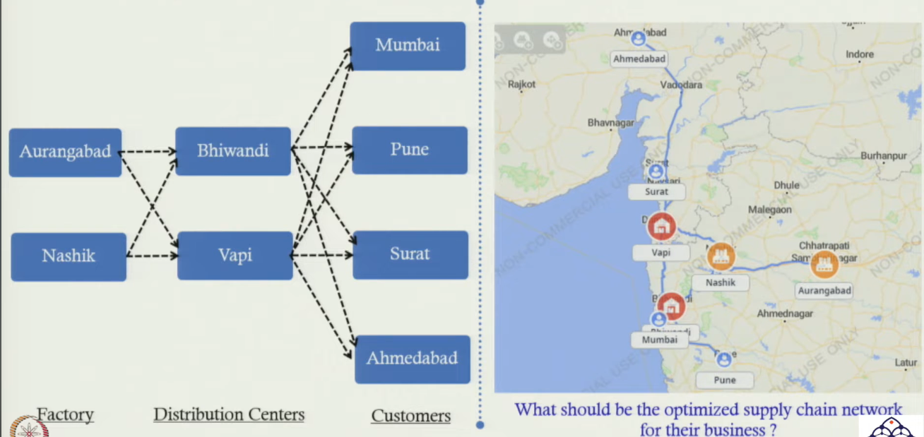
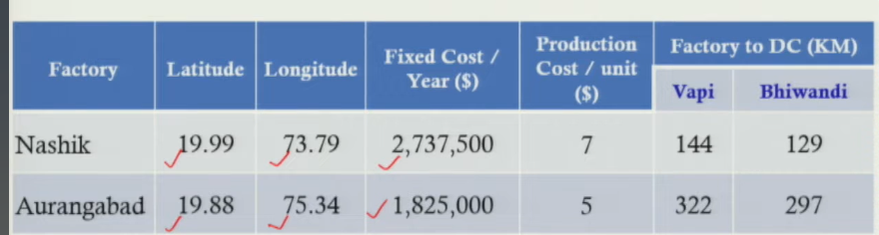
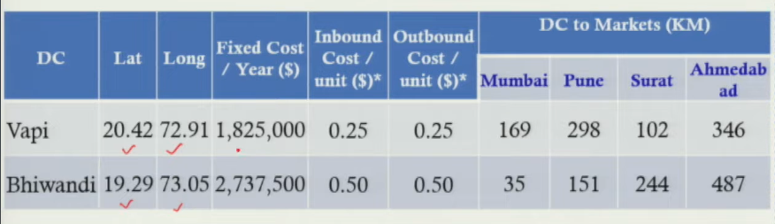
All Node Data
Node | Location | Fixed Cost/yr | Prod/Proc Cost/unit | Type | Key Distances (km)
Factory 1 | Nashik | (given) | $7/unit | Factory | → VAPI 144 km | → V1D 129 km
Factory 2 | Aurangabad | (given) | $5/unit | Factory | → VAPI 322 km | → V1D 297 km
DC 1 | VAPI (Vapi) | (given) | In/Out $0.25 | DC | → Mumbai 169 | Pune 298 | Surat 102 | Ahm 346
DC 2 | V1D (Viwandi) | (given) | In/Out $0.50 | DC | → Mumbai 35 | Pune 151 | Surat 254 | Ahm 487
Transport | All routes | — | $0.001/km/unit | — | Revenue: $15 per unit sold

Decisions to be Made
- (1) Open factory at Nashik, Aurangabad, or both?
- (2) Open DC at VAPI, V1D, or both?
- (3) Which factory supplies which DC (xij)?
- (4) Which DC serves which market — and how much (qjk)?

★ All 4 decisions must be optimized SIMULTANEOUSLY to maximize overall profit. Solving them separately gives a sub-optimal result.
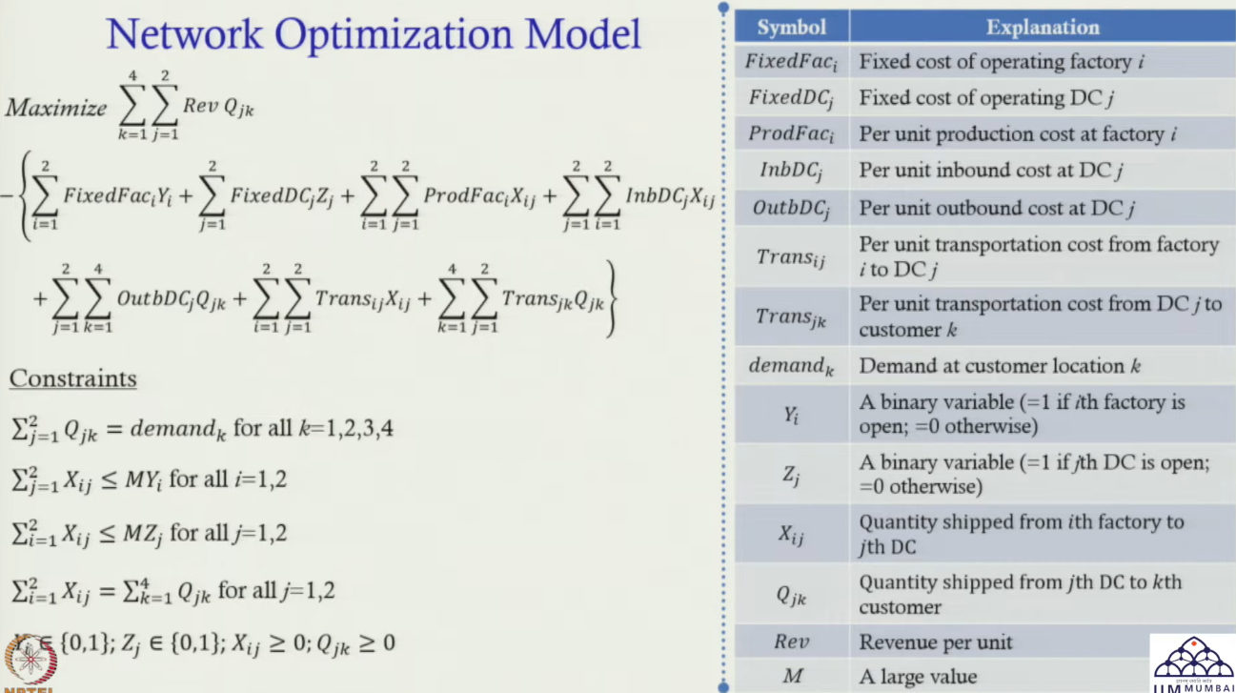
3. Decision Variables
Variable | Type | Meaning
yi | Binary {0,1} | = 1 if ith factory is OPEN; = 0 if NOT open. i = 1 (Nashik), i = 2 (Aurangabad)
zj | Binary {0,1} | = 1 if jth DC is OPEN; = 0 if NOT open. j = 1 (VAPI), j = 2 (V1D)
xij | Continuous ≥ 0 | Quantity shipped from ith factory to jth DC
qjk | Continuous ≥ 0 | Quantity shipped from jth DC to kth customer (k = 1..4 markets)

- M (Big M): a very large number. If a facility is open (y=1 or z=1), capacity = M (unlimited in this version). If closed (0), capacity = 0 — cannot send or receive anything.
- In practice: replace M with actual facility capacity to add realistic capacity constraints

4. Objective Function — Maximize Profit
- Profit = Revenue − All Costs

Maximize Z = Revenue − Factory Fixed Cost − DC Fixed Cost
− Production Cost − Inbound Cost − Outbound Cost
− Factory→DC Transport Cost − DC→Customer Transport Cost

Cost / Revenue Component | Expression | Explanation
Revenue | Σj Σk (Rev × qjk) | Rev = $15/unit. Total revenue = units sold to all customers × price.
Factory Fixed Cost | Σi (FC_factory_i × yi) | If yi = 0: cost = 0 (factory not open). If yi = 1: incur fixed cost.
DC Fixed Cost | Σj (FC_dc_j × zj) | If zj = 0: cost = 0 (DC not open). If zj = 1: incur fixed cost.
Production Cost | Σi Σj (PC_i × xij) | PC_i = production cost per unit at factory i ($7 Nashik, $5 Aurangabad).
Inbound Processing | Σi Σj (IB_j × xij) | IB_j = cost per unit for inbound processing at DC j ($0.25 VAPI, $0.50 V1D).
Outbound Processing | Σj Σk (OB_j × qjk) | OB_j = cost per unit for outbound processing at DC j.
Factory → DC Transport | Σi Σj (TC × dist_ij × xij) | TC = $0.001/km/unit. dist_ij = km from factory i to DC j.
DC → Customer Transport | Σj Σk (TC × dist_jk × qjk) | dist_jk = km from DC j to customer k.

- Key mechanism — binary variable in cost: if yi = 0 (factory not open) → fixed cost term = 0. Only incur cost if facility is open.

5. Constraints
Constraint | Expression | What it enforces
Demand satisfaction | Σj qjk = Dk ∀k | Total shipments from all DCs to customer k must equal customer k's full demand.
Factory capacity | Σj xij ≤ M × yi ∀i | If factory i is open (yi=1): can ship up to M (large number = unlimited). If closed (yi=0): capacity = 0 → cannot ship.
DC capacity | Σk qjk ≤ M × zj ∀j | If DC j is open (zj=1): can process up to M units. If closed (zj=0): cannot process anything.
Flow balance at DC | Σi xij = Σk qjk ∀j | What flows INTO each DC must equal what flows OUT. No inventory held at DC — pure pass-through.
Binary variables | yi, zj ∈ {0, 1} | Factory open/close and DC open/close are binary decisions.
Non-negativity | xij, qjk ≥ 0 | Flow quantities cannot be negative.

- Flow balance constraint is the critical new concept here — it ensures DCs don't hold inventory. Every unit that arrives at a DC must leave it.

★ Flow balance: Σi xij = Σk qjk for each DC j. Total inflow = total outflow. DCs are pass-through nodes, not storage points.

6. Excel Solver — Setup & Results
Solver Setting | Value / Detail
Set Objective | Cell E19 (Total Profit = Revenue − Cost)
To | Max (Maximize)
Changing Variables | D3:D4 (yi — factory open/close, binary) | D13:D14 (zj — DC open/close, binary) E3:F4 (xij — factory→DC flows) | E13:H14 (qjk — DC→customer flows)
Constraint 1 | E5:F5 ≤ E9:F9 (DC inflow ≤ DC capacity, which = M×zj)
Constraint 2 | E15:H15 = E17:H17 (demand satisfaction at all 4 markets)
Constraint 3 | H3:H4 ≤ K3:K4 (factory outflow ≤ factory capacity = M×yi)
Constraint 4 | I13:I14 = K13:K14 (flow balance: DC inflow = DC outflow)
Binary constraint | D3:D4 and D13:D14 set as binary (0 or 1 only)
Method | Simplex LP — objective and constraints are all linear (no spherical formula here)
Result | Aurangabad factory: OPEN. VAPI DC: OPEN. Nashik + V1D: CLOSED. Profit = ₹59,27,495

Why Simplex LP (not GRG Non-linear)?
- Distances are given as fixed inputs (km values) — not calculated via spherical formula
- Objective function and all constraints are linear in the decision variables
- Binary variables are handled as integer constraints — Simplex LP handles this (Mixed Integer LP)
- Contrast: GFA uses spherical formula → non-linear → needed GRG Non-linear

7. Optimal Solution — Results
Which Facilities to Open
- Factory: Aurangabad — OPEN (lower production cost $5/unit vs Nashik $7/unit)
- DC: VAPI — OPEN (lower inbound/outbound cost $0.25 vs V1D $0.50)
- Nashik factory: CLOSED. V1D (Viwandi) DC: CLOSED

Product Flow
- Aurangabad factory → VAPI DC → all required units shipped
- VAPI DC → Mumbai: 3,59,160 units (matches demand exactly)
- VAPI DC → Pune: 3,15,360 units
- VAPI DC → Surat: (demand matched)
- VAPI DC → Ahmedabad: (demand matched)

Optimal Profit
- Total Profit = ₹59,27,495 (= $59,27,495 in model currency)
- Both Excel Solver and Any Logistics give identical result — validates both approaches

★ Aurangabad + VAPI selected because: lower production cost at Aurangabad + lower DC processing cost at VAPI + proximity to high-demand markets (Mumbai, Pune, Surat).

8. Any Logistics — Network Optimization Module
Why Move to Any Logistics for Complex Problems
- When 4 SKUs are added (instead of 1 product) + daily demand → number of decision variables multiplies
- Excel cannot handle large MIP (Mixed Integer Programs) with many variables efficiently
- Any Logistics: built-in MIP solver + map visualization + route details + flow breakdown

Data Entry in Any Logistics — Network Optimization Module
- Customers: Pune, Mumbai, Ahmedabad, Surat — 4 markets
- Facilities: Aurangabad (factory), Nashik (factory), VAPI (DC), V1D (DC)
- Demand: per day per SKU (4 SKUs × 4 markets = 16 demand entries)
- Revenue: $15 per unit (for each SKU)
- Facility expenses: fixed cost per day (e.g., ₹7,500/day × 365 = annual fixed cost)
- Objective configured: Revenue − Fixed cost − Inbound − Outbound − Production − Transport
- Run period: Jan 1 2021 – Dec 31 2021 (or set to actual planning horizon)
- Run → solution in seconds — same result as Excel: Aurangabad + VAPI, profit = ₹59,27,495

Additional Outputs from Any Logistics
- Map visualization: actual road routes shown from Aurangabad → VAPI → customers
- Flow details: Aurangabad → VAPI: SKU1 = 3,13,900 units, distance = X km, transport cost shown
- Per-route breakdown: every factory→DC and DC→customer flow listed with units, km, cost
- Multiple cost layers: processing cost, flow cost, transport cost shown separately per arc

★ Any Logistics shows the actual road route — not just straight-line connections. This is key for real-world delivery planning where road distance > straight-line distance.

Session Summary
- Context: demand doubled → need new factory + DC. Candidates: Nashik/Aurangabad (factory), VAPI/V1D (DC)
- 4 decisions: which factories to open (yi), which DCs to open (zj), factory→DC flows (xij), DC→customer flows (qjk)
- Objective: Maximize Profit = Revenue − all 7 cost components (fixed + variable + transport)
- Big M trick: if facility closed (0) → capacity = 0 → cannot send/receive. Open (1) → capacity = M (unlimited)
- Flow balance: inflow to DC = outflow from DC. DCs are pass-through — no inventory held.
- Solver: Simplex LP (linear model, binary integer constraints). Contrast with GFA which used GRG Non-linear.
- Result: Aurangabad factory + VAPI DC. Profit = ₹59,27,495. Identical from Excel and Any Logistics.
- Any Logistics extra: road routes, per-arc flow breakdown, multi-SKU, scales to 1000s of nodes

★ Exam Tip: 4 decision variables in network optimization: yi (factory open/close, binary), zj (DC open/close, binary), xij (factory→DC flow, continuous), qjk (DC→customer flow, continuous).
★ Exam Tip: Big M constraint: Σj xij ≤ M × yi. If yi=0 → capacity=0 → cannot ship. If yi=1 → capacity=M (unlimited). Replace M with actual capacity to add real capacity limits.
★ Exam Tip: Flow balance at DC: Σi xij = Σk qjk for each j. All inflow must equal all outflow — DCs don't hold inventory. This is unique to multi-tier network models.
★ Exam Tip: Network optimization solver = Simplex LP (linear). GFA solver = GRG Non-linear (spherical distance formula). Knowing WHY each method is used is key.

